**Task-1**

**Human services (Client Side Human Service, Heritage Service)**

**Heritage Service :**

Heritage human services, you use existing artifacts, such as coaches, heritage coaches, and stock controls, to create user interfaces for business process management. You create and edit heritage human services in the IBM Process Designer desktop editor, run them on the server, and use them to supply user interfaces to web-based applications such as IBM Process Portal. When you build a heritage human service in the Process Designer desktop editor, you can use coaches or heritage coaches, server scripts, services, and events to create a service flow that is run and tested on the server.

**Client Side Human Service:**

Human services that were added in IBM BPM V8.5.5. When you use client-side human services, you can use web technology to improve human-service performance and provide support for case management and process management. You create and edit client-side human services in the Process Designer web editor, run them on the client-side in the web browser, and use them to call the server for data when necessary. When you build a client-side human service, you can use coaches, client-side scripts, services, events to create a service flow that is run, tested, and refined entirely in a web browser.

**Task Overview:**

Consider Account Opening is a process where we have to show request(request comes from different sources like Bank Agents, Online Requests, Offline Requests and from Mobile Applications) can be created by requestor(Maker), for a customer to open Account in the Bank. There a requestor will see a screen which contains two parts i.e., one side is fields like name, date of birth, etc and another side is to uploaded documents like AADHAR Card, address proofs, etc . After validating and modifying the each and every details in the screen that will submitted to the verify officer(Checker).

Note: Let us assume third party applications already processed the data of a customer and placed the documents in EDMS(Document Store)/Filenet with the customer name with unique folder ID. One row was inserted in the DB with the customer unique ID. Whenever a folder and details uploaded in db Middleware(IIB flow) will be responsible to create the instance in BPM for that customer with the Username, folder Id, Customer Unique Id(Customer Identification Number) as inputs.

**Solution:**

Create a Client side/Heritage (or both) human services, Now the BPM Developer has to create a unique Id for the customer(Account Number) and show it on a left half of the screen with Account Number with Customer details which were available in DB, in right side he has to bring and show the documents which were available in EDMS(Document Store)/FileNet. To show the document content and files in one screen the developer has to use dual section component. Now give control to the Maker, he will modify the left side fields by seeing the available documents in right side.

**Required Components:**

1.IBM BPM v 8.x

2.FileNet/Any EDMS/BPM Default document store

3.DB2/Oracle/SQL

**Required Fields :**

**Personal Info :**

Customer Name

Type of account: Current account /saving account

Pan card Number

Passport Number

Aadhar Number

DOB

Email Id

**Contact Info:**

Contact Number

Present Address

Permanent Address

PO Box No

**Work Details:**

Employee Type : Salaried / Self / Business

Company Name

DOJ

Office Address

Monthly Income

Role...........etc.

**Implementations:**

**Step1:** Create an Account Opening process BPD and drag a user activity as shown below

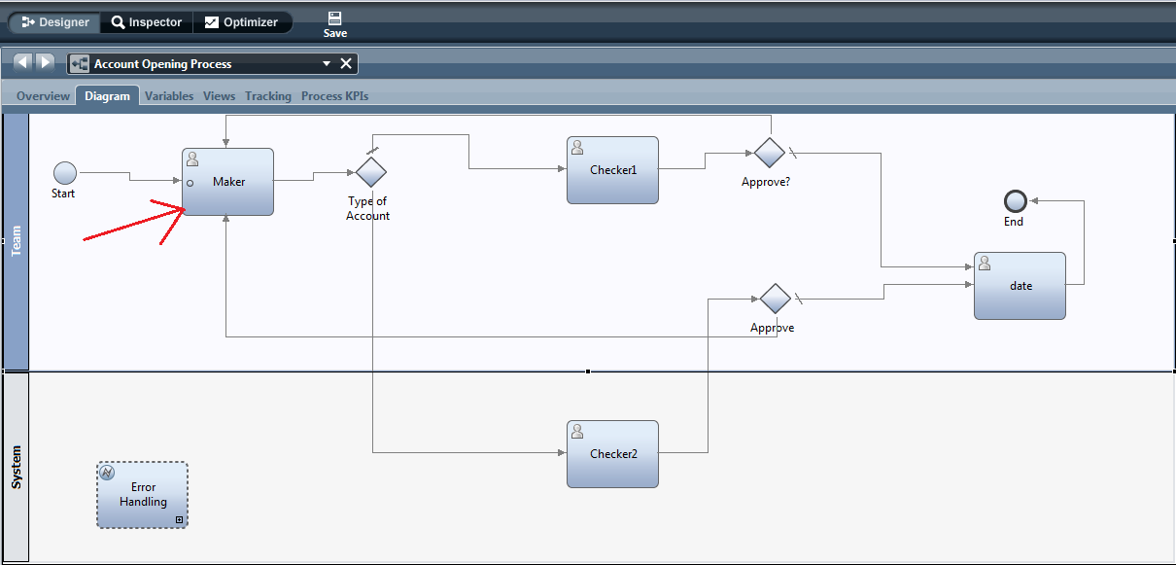

**Step2:**  Create a Heritage Human Service for maker and implement the required fields in a Coach.

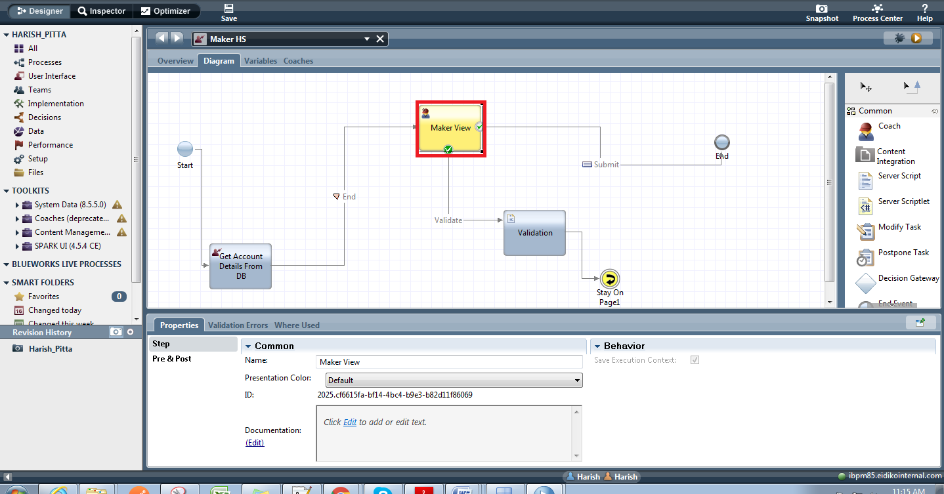

* To implement Maker view create Business Objects for Work Details, Personal Information and Contact details and drag the variables in Coach and also drag document list and document viewer.

